**Intro**

After importing the .unitypackage, you will see 3 different versions of the controller.

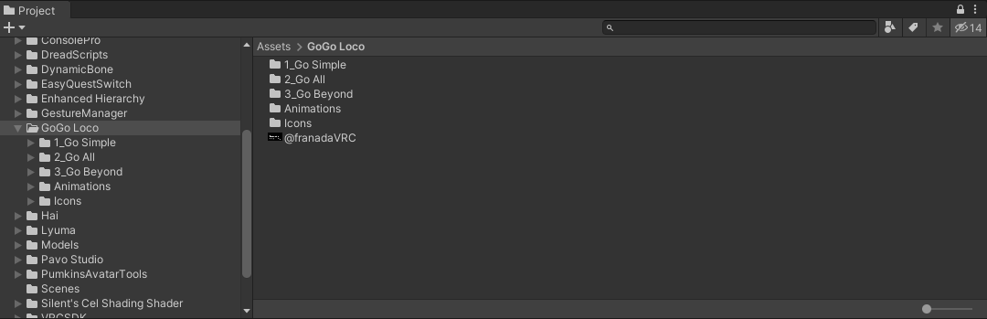

In each, you will see 2 versions. One has WD at the end.

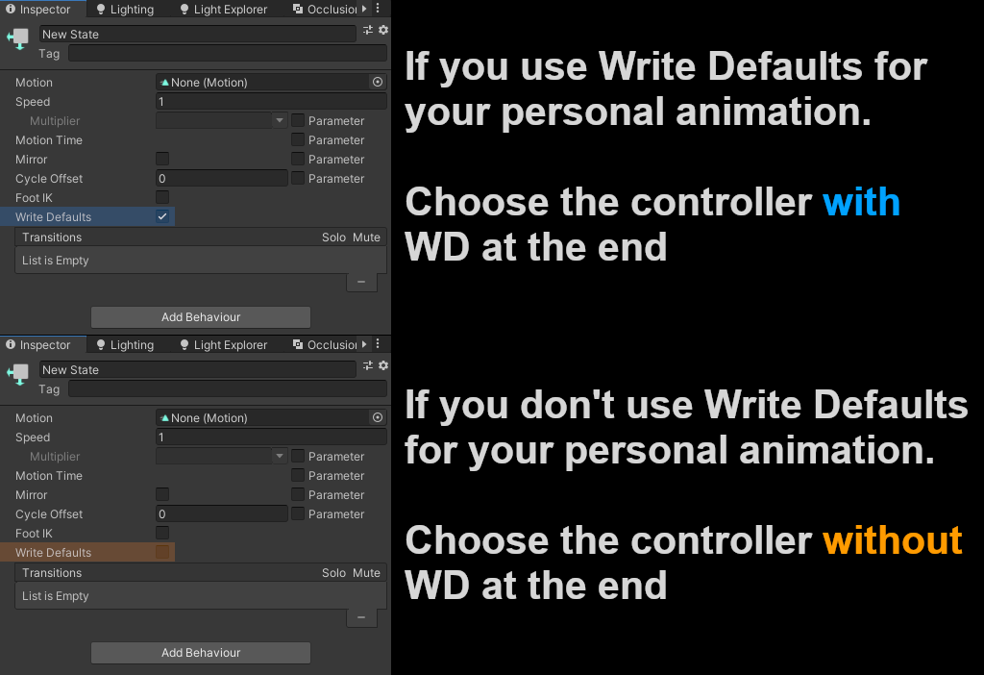

Go Simple :

* Use 3 parameter bits.
* Toggle for disabling legs, jump and locomotion.

Go All :

* Use 19 parameter bits.
* Toggles for disabling legs, jump and locomotion.
* Fake playspace with various poses.
* Emotes can be sped up or slowed down.
* Special locomotion for game worlds such as Jet Set Radio Festival and Super VR Ball.
* A toggles that hide your avatar/nameplate under the floor.

Go Beyond : Only work with Write Defaults off / Fly PC only but scale work on both

* Use 20 parameter bits.
* Toggles for disabling legs, jump and locomotion.
* Fake playspace with various poses.
* Emotes can be sped up or slowed down.
* Special locomotion for game worlds such as Jet Set Radio Festival and Super VR Ball.
* A toggles that hide your avatar/nameplate under the floor.
* A radial that scales your avatar.
* 2 toggles to enable a fly collider
  + Trigger : The more you press the right trigger. The faster you will go
  + Radial : The radial makes you go faster but not the trigger.

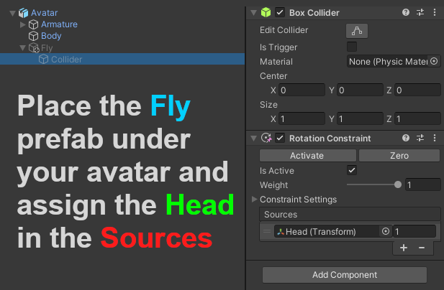

**Installation**

Copy all the parameters you see to yours.

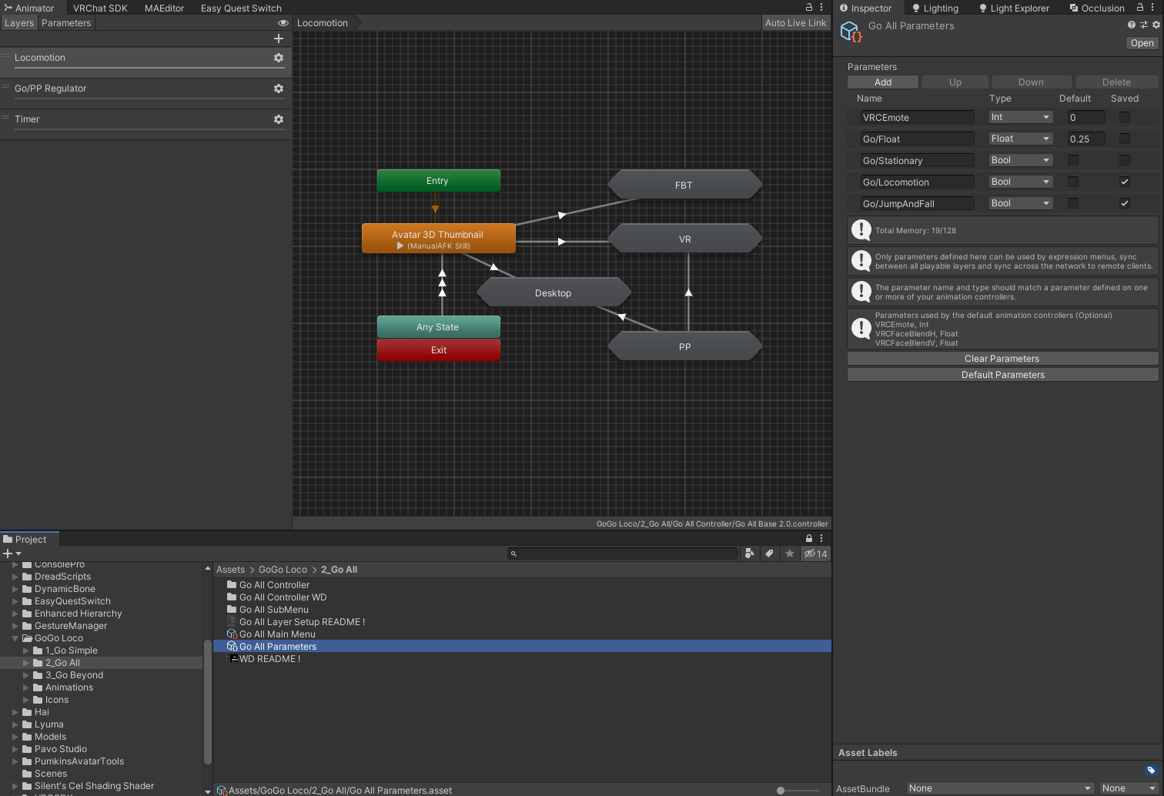

Add a submenu controller and plug the main menu.

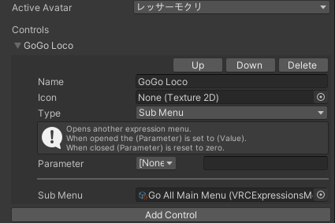

In the avatar descriptor, assign all the controllers.

The number beside de Base is height. Choose the one that fits your avatar size the closest.

Uncheck Force Locomotion animations for 6 point tracking.

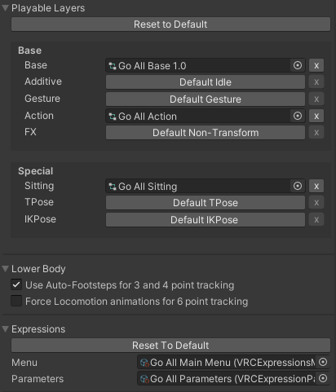

To prevent your avatar to get occlude when going up/ down you can expend your boundary on your skinned mesh

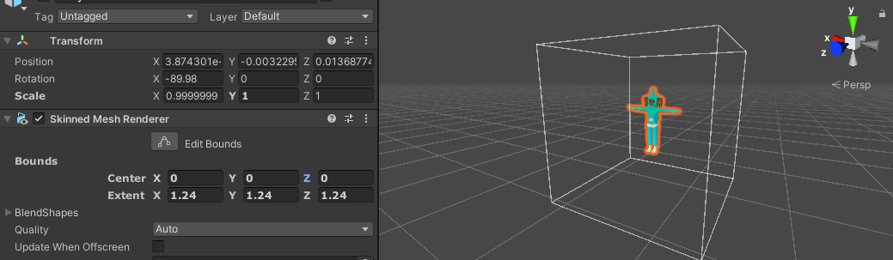

You're done.

**Change the turntable animation**

In the base controller, change the animation in the state Avatar 3D Thumbnail

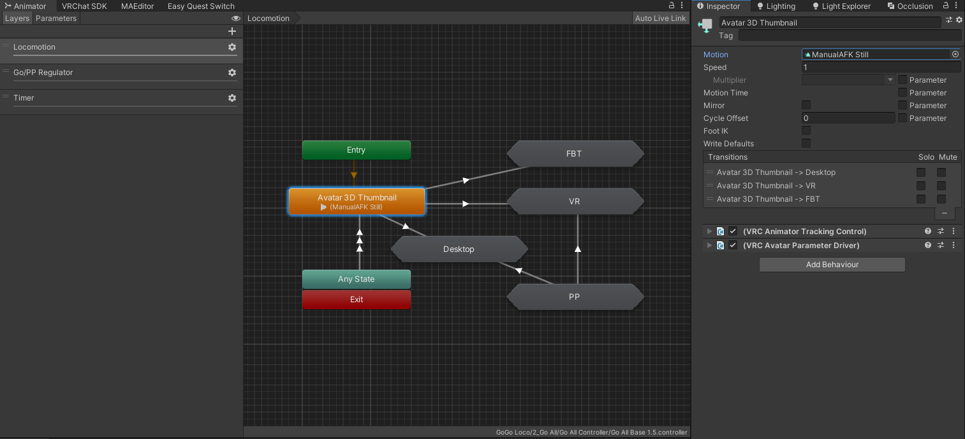

**Add more emotes**

Open the action controller and double click the lozenge name Standing Emotes

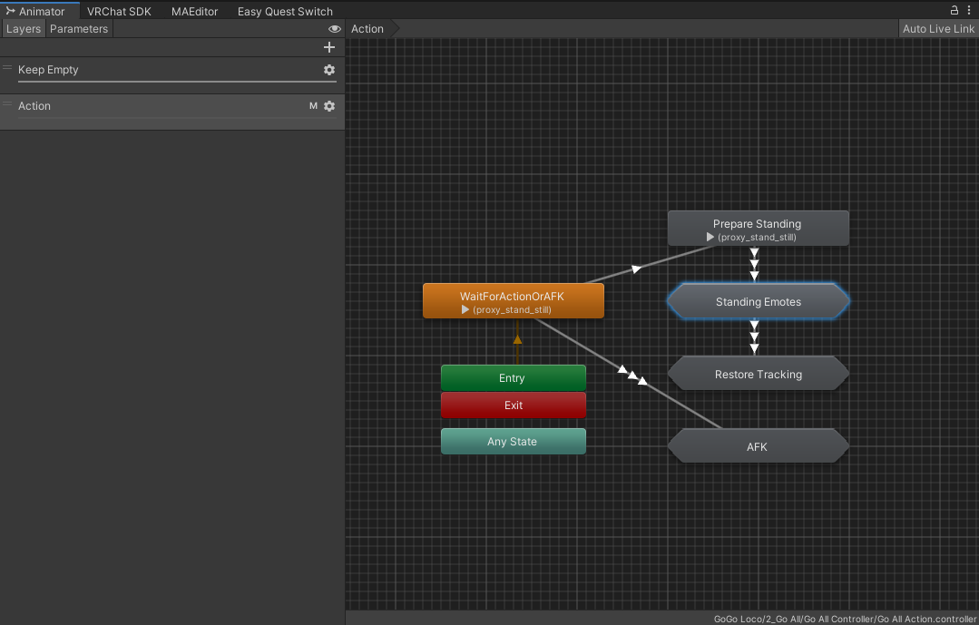

The 1-8 are the default emotes. To add a new one open one of the two below it.

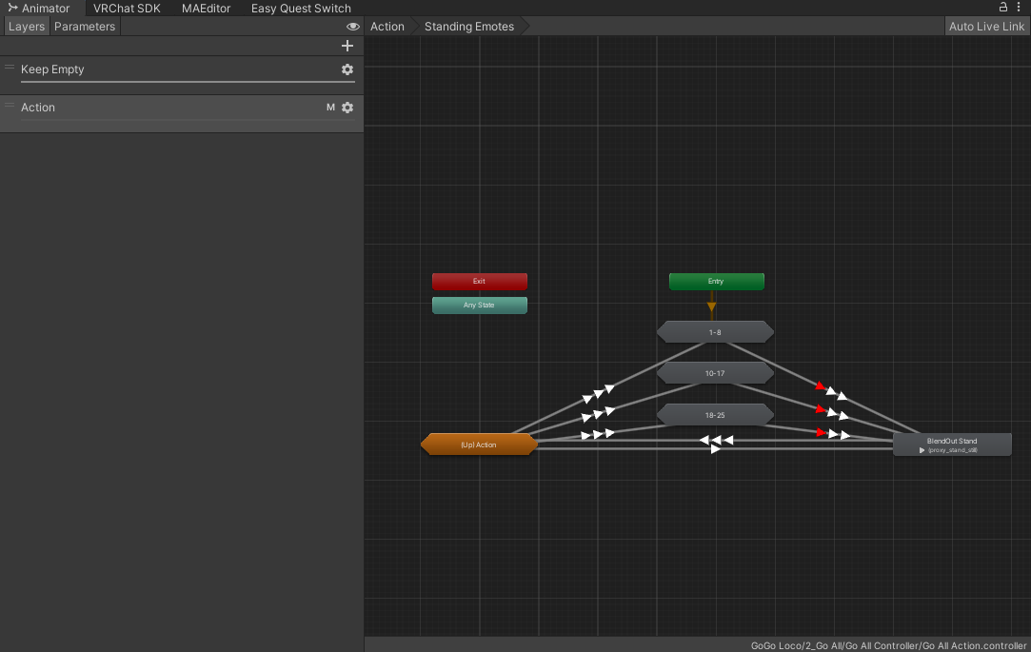

Change animation with the one wanted.

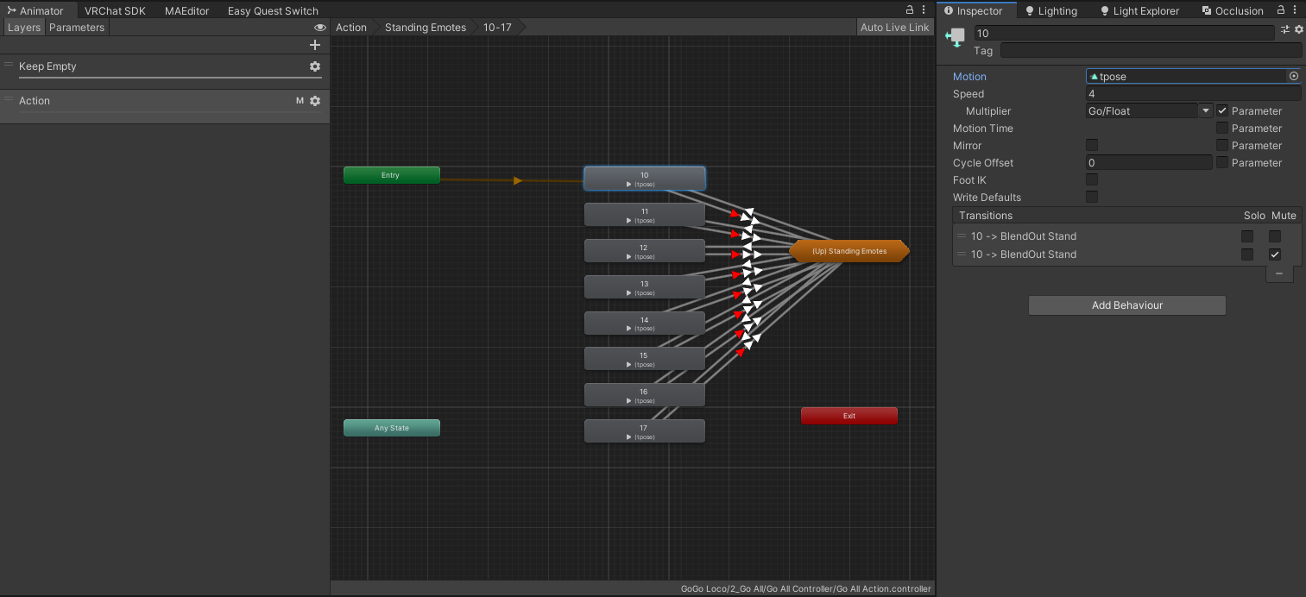

Add a toggle controller and assign the VRCEmote parameter and with the number that matches the state name. 10 in this case.

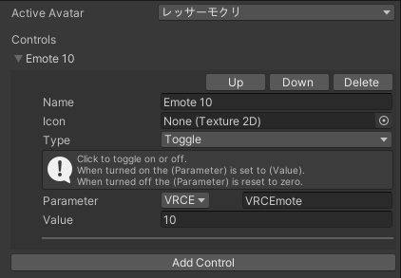

If you want to change the speed of the animation use a type Radial Puppet with the Parameter Go/Float

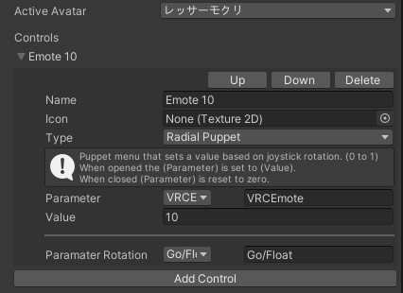

**Change the AFK**

Open the action controller and double click the lozenge name AFK

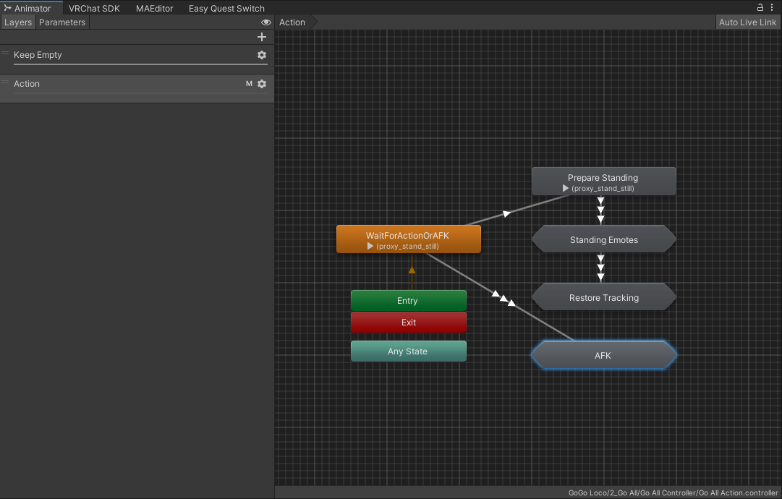

There you can change the afk animation depending if you are standing, crouching or proning. Only change the first 2 state animations by yours. Let the third one proxy_stand_still.

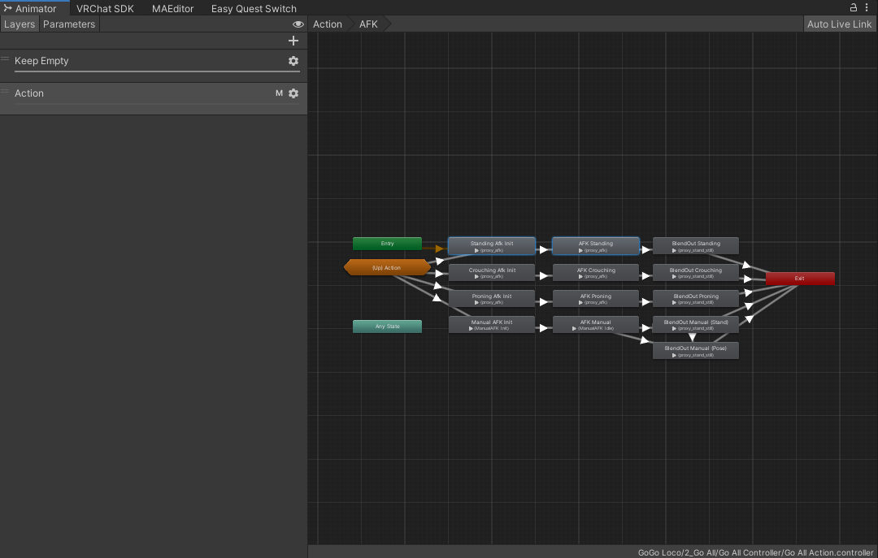

**Add more poses**

Open the Base controller and double click the lozenge name PP

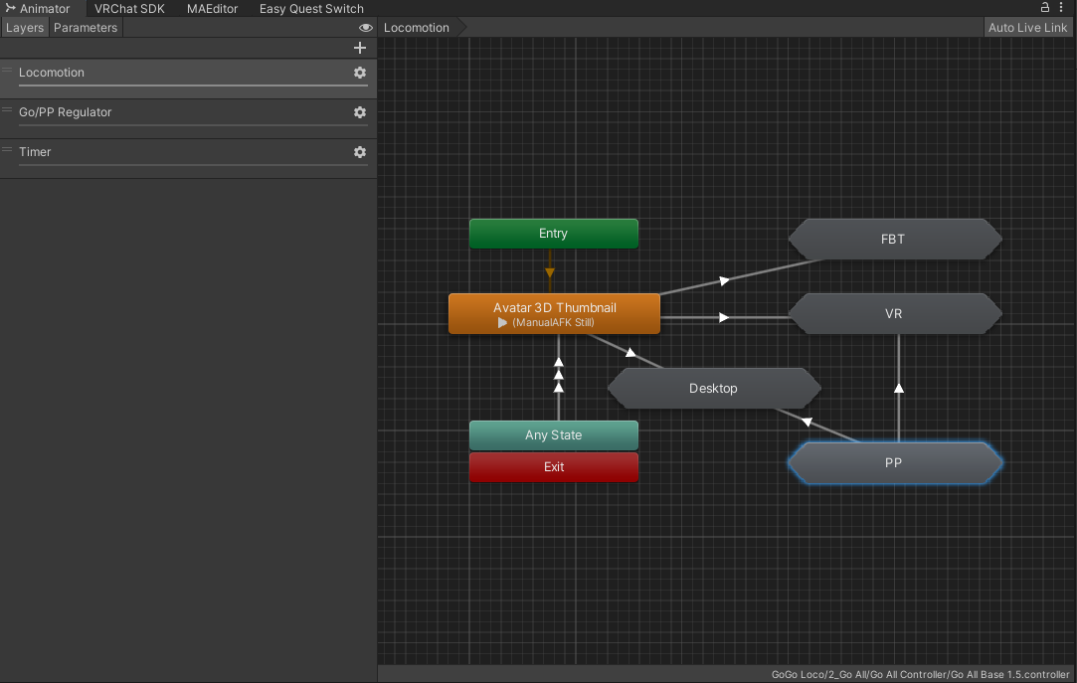

254 to 240 are populated by the animations I provide. To add more poses, select one below.

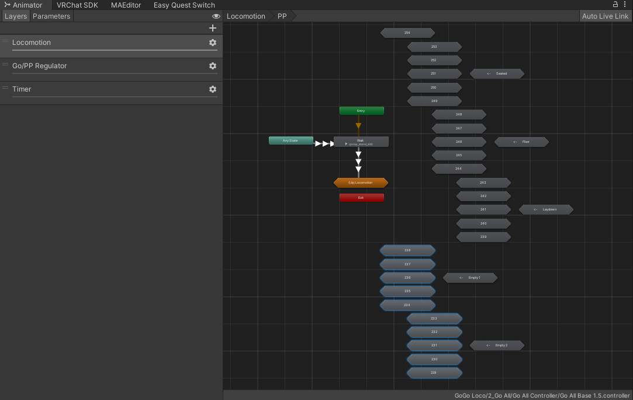

Use the same animation in the 4 states inside.

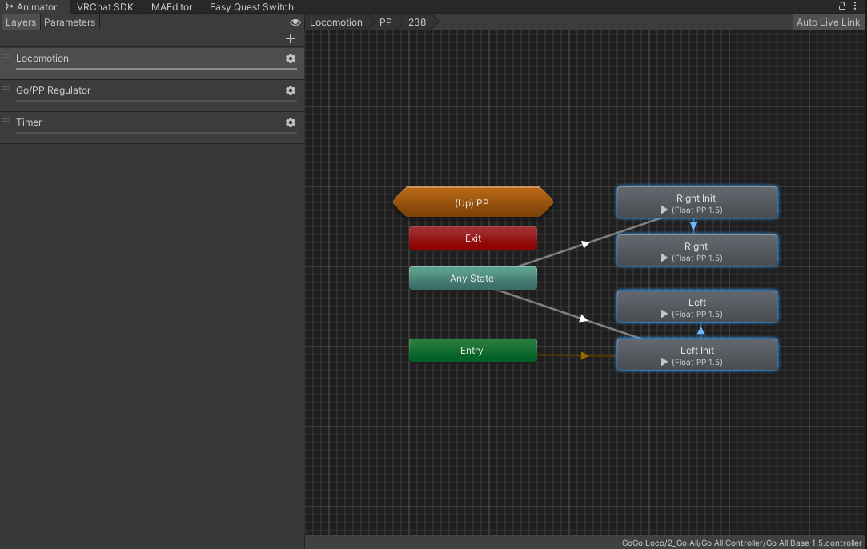

Add a button controller and assign the VRCEmote parameter and with the number that matches the state name. 238 in this case.

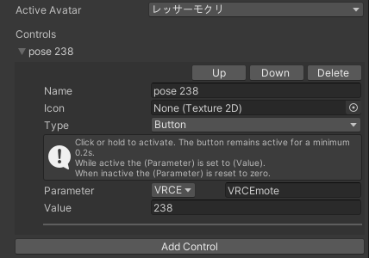

Now you have more poses but they won’t move up and down and might look a little weird. We need to edit the animation file.

Open your animation and make sure the head is aligned in the center by animating the Root.x/z value. You need all the Based Upon to be original and the Bake Into Pose on. Loop Time off.

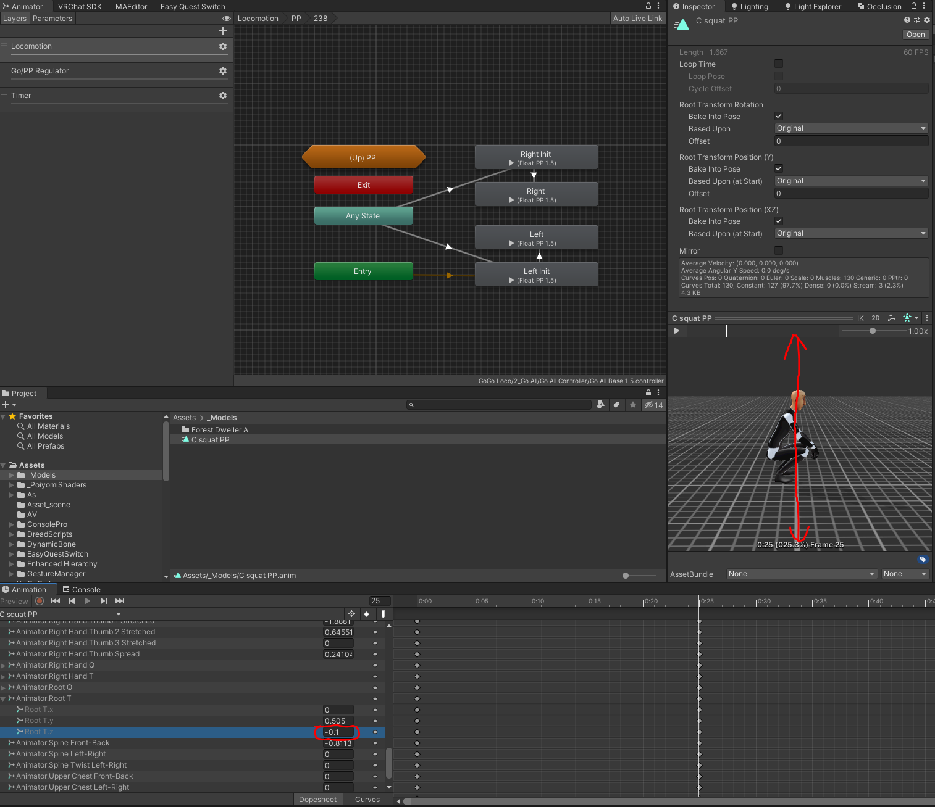

The frame 25 is the default height. Animate the Root.y

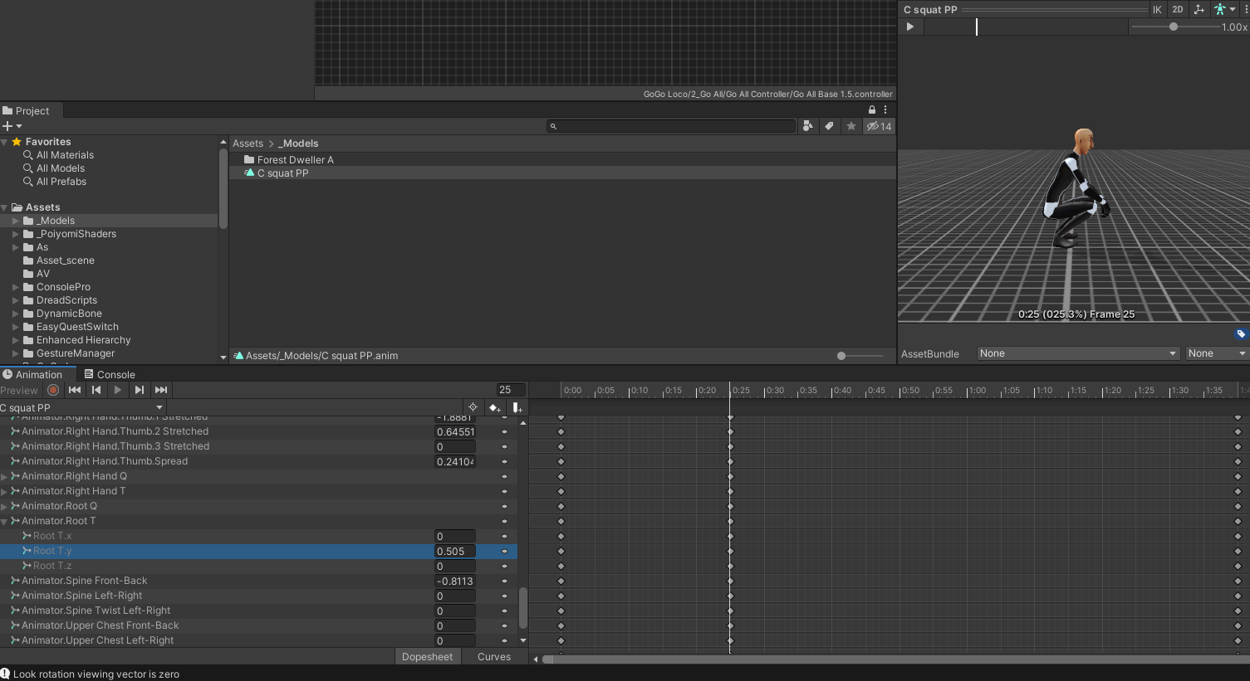

The frame 0 is the head just above the ground. The reason, VRChat doesn't allow something that is tracking to go below the ground. Animate the Root.y

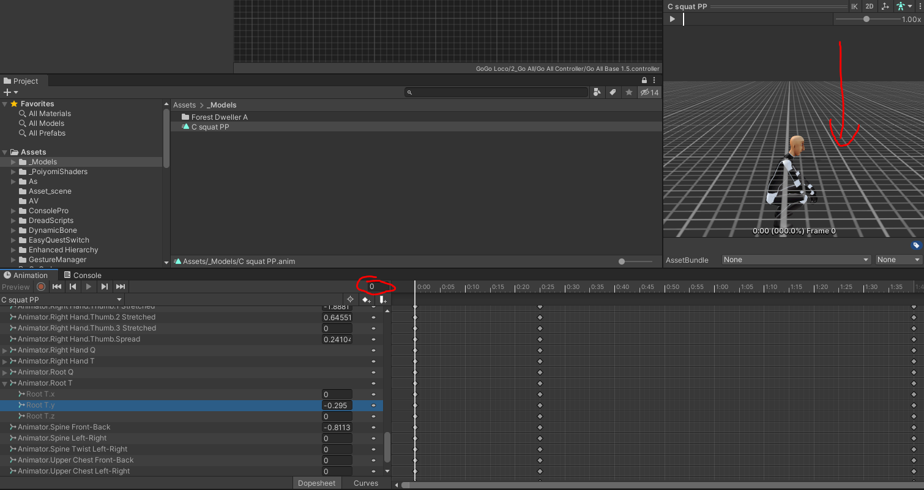

The frame 100 is in the air. Animate the Root.y as high as you want but be reasonable.

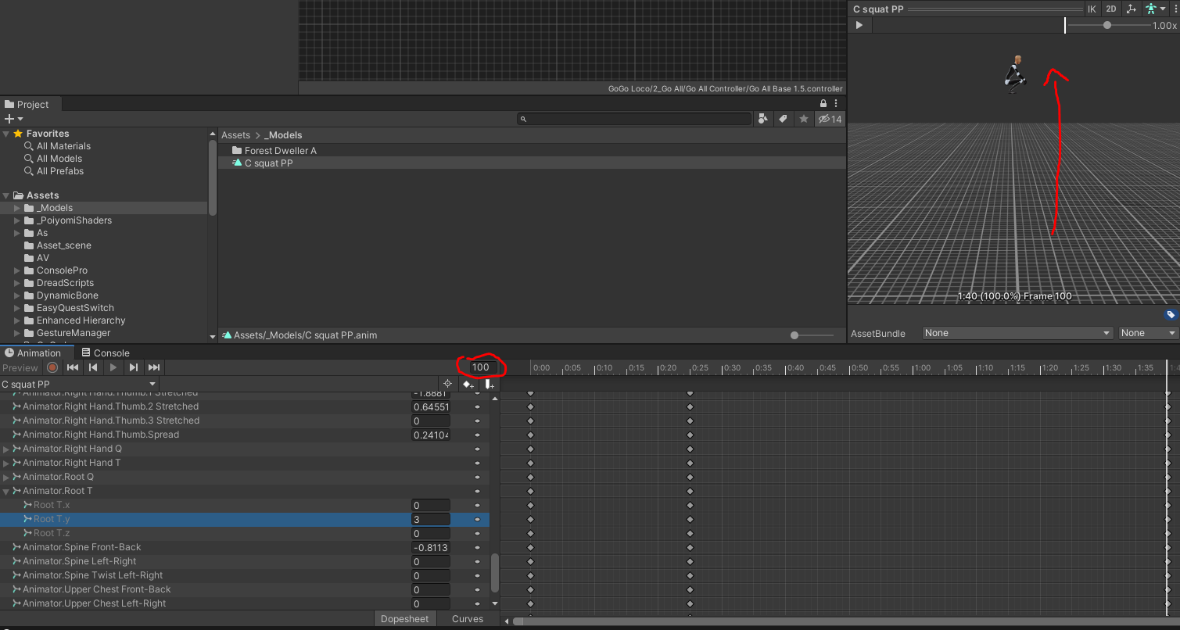

To have a linear motion when using a radial. Go in the Curves tab, select the 3 frames of the Root.y, right click and select linear.

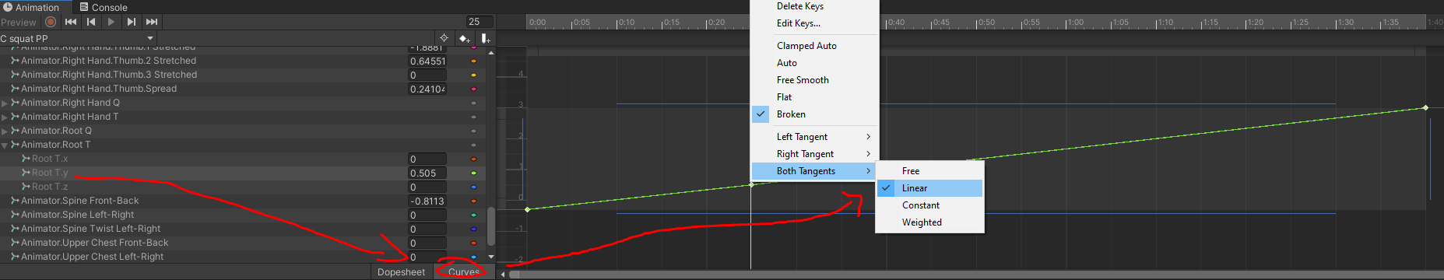

**Change the standing/crouch/prone idle animation**

Open the Base controller and double click the lozenge name Desktop or VR

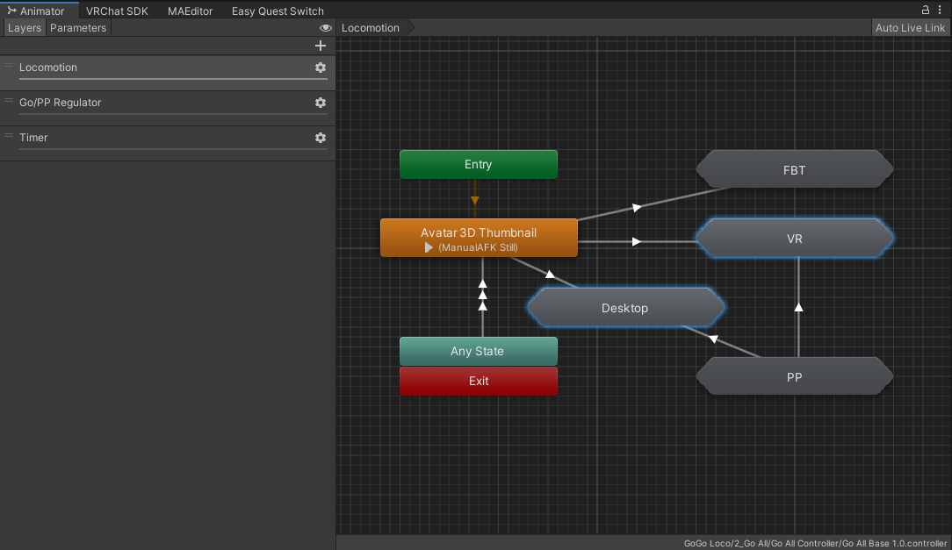

Change the animation in the state label No Motion.

